**Screenshots**

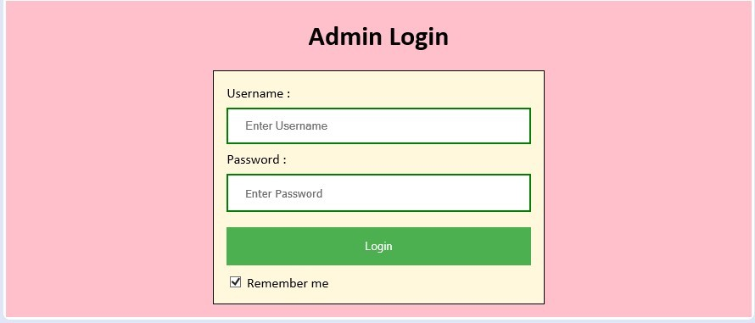

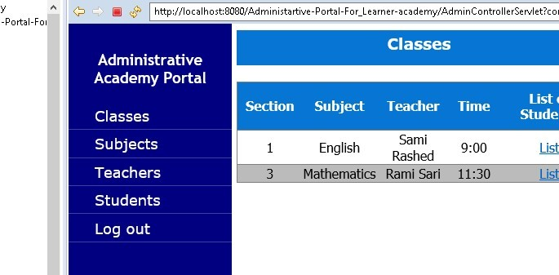



'- Portal- F oi

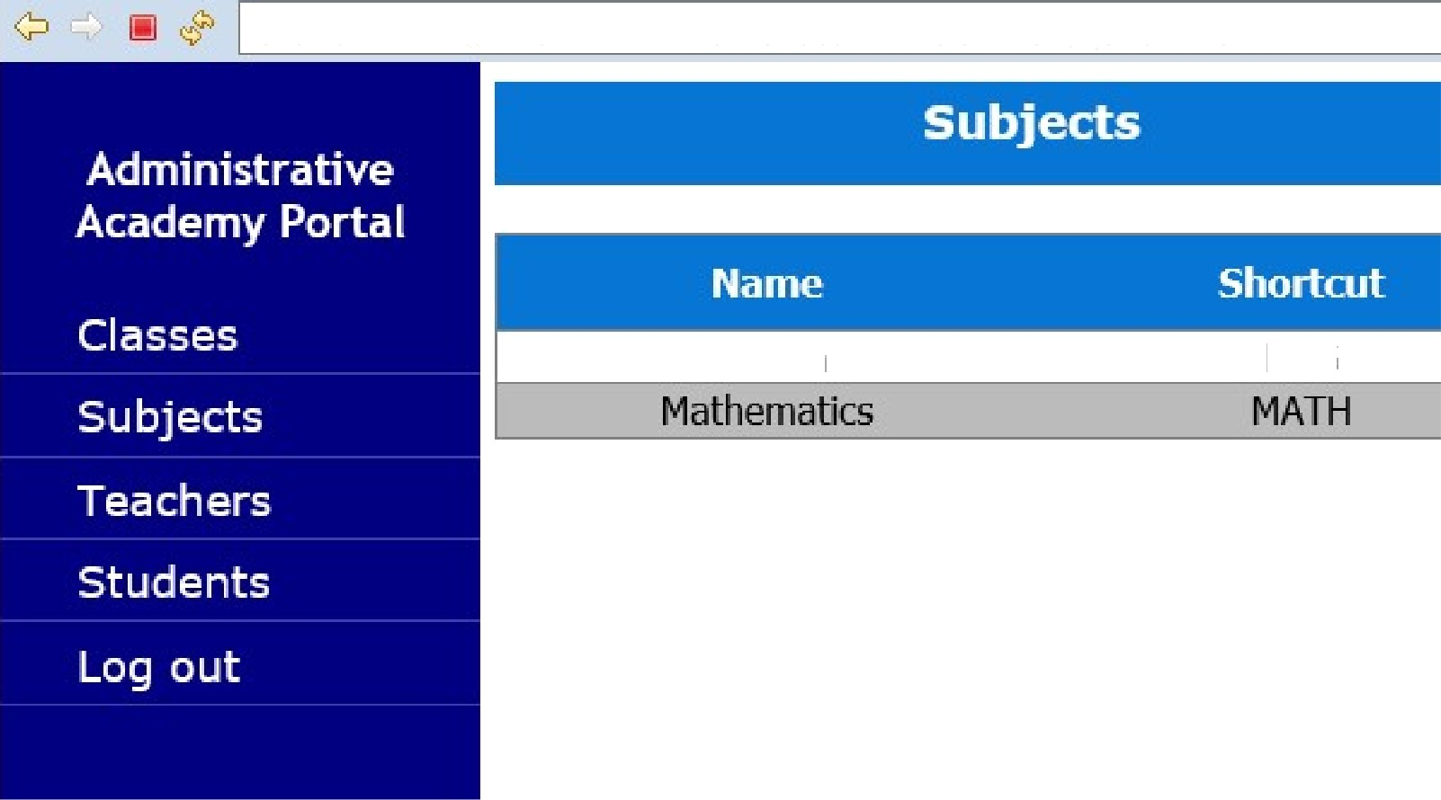

http://localhost:8080/Administartive -Portal- F or Learn e r- a c a de my/AdminC ontroIIerServlet?c o

English

ENG

*o Fo

* /a

ono !//

t 080/Administartive-Portal-for Learner-academy/AdminControllerServlet?coi



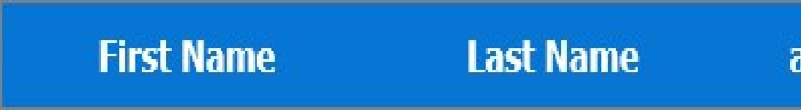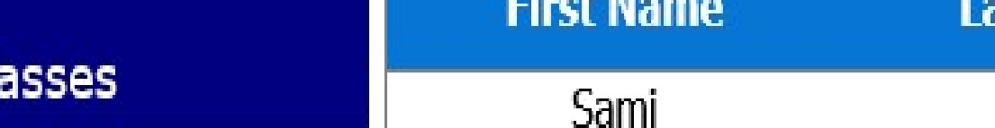

RasneJ

, &mi

Sari

